Project: XXX

Data Model / Data Structure

Database Model Diagrams

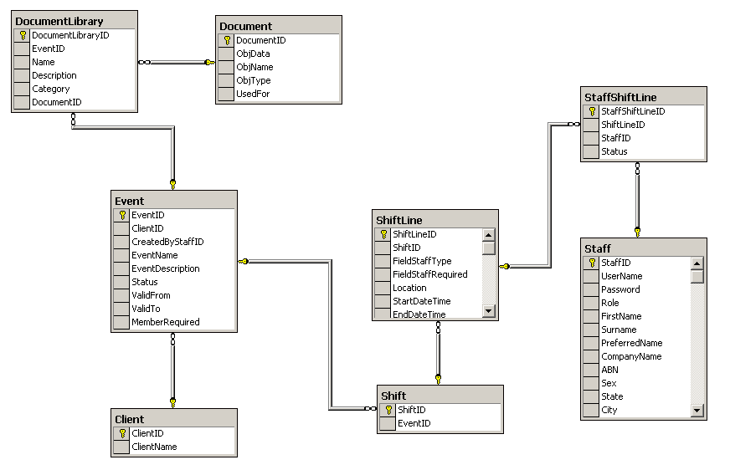
Figure 01 – main diagram
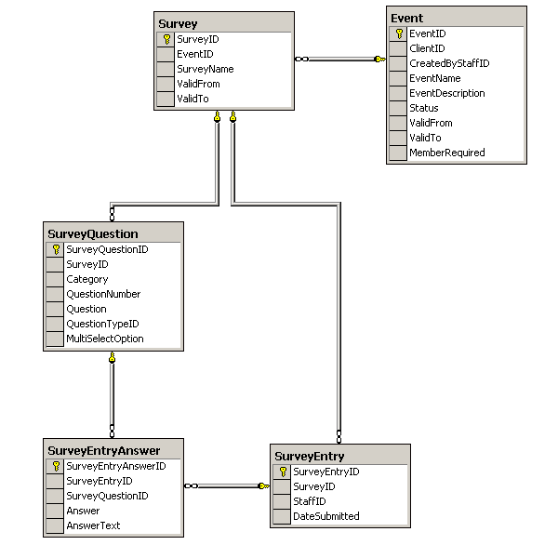
Figure 02 – Feedback for Event diagram

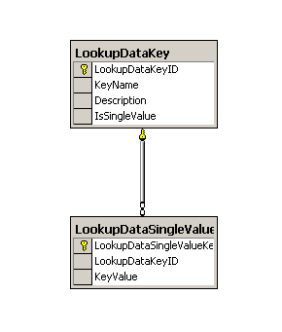
Figure 03 – Data Lookup diagram

Detail Database Design
This section listing all details information about the database design

Event Table
Column | Type | Description | Default
EventID | INT | PK | Not null
ClientID | INT | FK | Not null
CreatedByStaffID | INT | FK | Not null
EventName | VARCHAR (255) |  | Not null
EventDescription | VARCHAR (255) |  | “”
Status | VARCHAR (255) | LookupDataKey – Event Status | Not null
ValidFrom | DATETIME |  | Not null
ValidTo | DATETIME |  | Not null
MemberRequired | INT | Number of member required | Not null

Client Table
Column | Type | Description | Default
ClientID | INT | PK | Not null
ClientName | VARCHAR (255) |  | Not null

TrainingShift Table
Column | Type | Description | Default
TrainingShiftID | INT | PK | Not null
EventID | INT | FK | Not null
ShiftName | VARCHAR(255) |  | Not null
Location | VARCHAR (255) |  | Not null
StartDateTime | DATETIME |  | Not null
EndDateTime | DATETIME |  | Not null

Shift Table
Column | Type | Description | Default
ShiftID | INT | PK | Not null
EventID | INT | FK | Not null

ShiftLine Table
Column | Type | Description | Default
ShiftLineID | INT | PK | Not null
ShiftID | INT | FK | Not null
FieldStaffType | VARCHAR (255) | LookupDataKey – Field Staff Type | Not null
FieldStaffRequired | INT | Number of field Staff required | Not null
Location | VARCHAR (255) |  | Not null
StartDateTime | DATETIME |  | Not null
EndDateTime | DATETIME |  | Not null

StaffShiftLine Table
Column | Type | Description | Default
StaffShiftLineID | INT | PK | Not null
ShiftLineID | INT | FK | Not null
StaffID | INT | PK | Not null
Status | VARCHAR (255) | LookupDataKey – Staff ShiftLine Status | Not null

Staff Table
Column | Type | Description | Default
StaffID | INT | PK | Not null
Username | VARCHAR (30) |  | Not null
Password | VARCHAR (30) |  | “”
Role | VARCHAR (255) | LookupDataKey - Role | Not null
SpecialSkills | VARCHAR(255) | LookupDataKey – Special Skills Type | Not null
FirstName | VARCHAR (30) |  | Not null
Surname | VARCHAR (30) |  | Not null
PreferredName | VARCHAR (50) |  | “”
CompanyName | VARCHAR (255) |  | “”
ABN | VARCHAR (255) |  | “”
Sex | VARCHAR (255) | LookupDataKey – Sexual Type | “”
State | VARCHAR (255) | LookupDataKey – State | “”
City | VARCHAR (255) |  | “”
Region | VARCHAR (255) | LookupDataKey – Region | “”
PhoneHome | VARCHAR (255) |  | “”
PhoneWork | VARCHAR (255) |  | “”
Mobile | VARCHAR (255) |  | “”
FaxHome | VARCHAR (255) |  | “”
FaxWork | VARCHAR (255) |  | “”
Email | VARCHAR (255) |  | Not null
DOB | DATETIME |  | 1900-1-1
DriverLicense | VARCHAR (255) | LookupDataKey – Driver License Options | “”
LicenseType | VARCHAR (255) | LookupDataKey – Driver License Type | “”
LicenseNumber | VARCHAR (255) |  | “”
LicenseIssueState | VARCHAR (255) | LookupDataKey – State | “”
LicenseExpiryDate | DATETIME |  | “”
AccesstoCar | VARCHAR (255) | LookupDataKey – Access To Car Options | “”
UsualRole | VARCHAR (255) | LookupDataKey – Field Staff Type | “”
Bank | VARCHAR (255) |  | “”
AccountNumber | VARCHAR (255) |  | “”
BSBN | VARCHAR (255) |  | “”
EmergencyContactPerson | VARCHAR (255) |  | “”
EmergencyContactRelationships | VARCHAR (255) | LookupDataKey – Relationships Type | “”
EmergencyContactPhone1 | VARCHAR (255) |  | “”
EmergencyContactPhone2 | VARCHAR (255) |  | “”
ShirtSize | VARCHAR (255) | LookupDataKey- T-Shirt Size | “”
ShoeSize | FLOAT | 1 decimal point | “”
Height | FLOAT |  | “”
PrimaryPhotoID | INT | FK to Document | NOT NULL
SecondaryPhotoID | INT | FK to Document | NOT NULL

Document Table
Column | Type | Description | Default
DocumentID | INT | PK | Not null
ObjData | IMAGE |  | Not null
ObjName | VARCHAR (255) |  | Not null
ObjType | VARCHAR (255) |  | Not null
UsedFor | VARCHAR (255) |  | Not null

DocumentLibrary Table
This table also will be used as Picture Gallery.
Column | Type | Description | Default
DocumentLibraryID | INT | PK | Not null
EventID | INT | FK to Event table | Not null
Name | VARCHAR (255) |  | Not null
Description | VARCHAR (255) |  | “”
Category | VARCHAR (255) | LookupDataKey – Document Category | Not null
DocumentID | INT | FK to Document table | Not null

Survey Table
Column | Type | Description | Default
SurveyID | INT | PK | Not null
EventID | INT | FK to Event | Not null
SurveyName | VARCHAR (255) |  | Not null
ValidFrom | DATETIME |  | ‘1900-1-1’
ValidTo | DATETIME |  | ‘1900-1-1’

SurveyQuestion Table
Column | Type | Description | Default
SurveyQuestionID | INT | PK | Not null
SurveyID | INT | FK to Survey | Not null
Category | VARCHAR (255) | LookupDataKey – Survey Question Category
QuestionNumber | VARCHAR (30) |  | Not null
Question | VARCHAR (255) |  | Not null
QuestionTypeID | VARCHAR (255) | LookupDataKey – Question Type
MultiSelectOption | VARCHAR (255) |  | “”

SurveyEntry Table
Column | Type | Description | Default
SurveyEntryID | INT | PK | Not null
SurveyID | INT | FK to Survey | Not null
StaffID | INT | FK to Staff | Not null
DateSubmitted | DATETIME |  | Not null

SurveyEntryAnswer Table
Column | Type | Description | Default
SurveyEntryAnswerID | INT | PK | Not null
SurveyEntryID | INT | FK | Not null
SurveyQuestionID | INT | FK | Not null
Answer | VARCHAR (255) | Yes/No | “”
AnswerText | VARCHAR (255) | Text/Numeric/Multi-select | “”

LookupDataKey Table
Column | Type | Description | Default
LookupDataKeyID | INT | PK | Not null
KeyName | VARCHAR (255) |  | Not null
Description | VARCHAR (255) |  | “”
IsSingleValue | INT |  | 1

LookupDataSingleValueKey Table
Column | Type | Description | Default
LookupDataSingleValueKeyID | INT | PK | Not null
LookupDataKeyID | INT | FK | Not null
KeyValue | VARCHAR (255) |  | Not null

